Some of the frequently used cost functions for Machine Learning:
- MSE (Mean Squared Error)
- RMSE (Root Mean Squared Error)
- binary cross-entropy
- categorical cross-entropy
Two of them are explained in comprehensive format below for quick revision. Enjoy “the echo” effect!

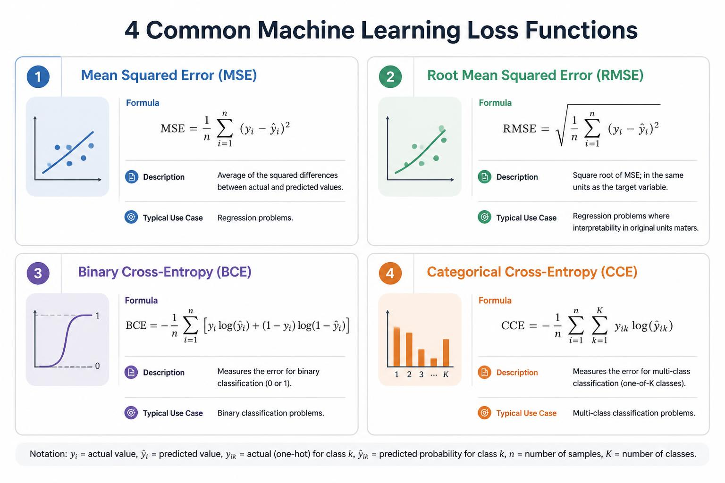

MSE = Mean Squared Error
the average of the squared differences between actual and predicted values.
- Use: Regression loss/metric; penalizes larger errors more than MAE.
- Interpretation: Units are squared units of the target (not directly comparable to target scale).
- Formula:
MSE = (1/n) * Σ (y_i - ŷ_i)^2
where y_i = actual, ŷ_i = predicted, n = number of observations.
- Relationship to RMSE: RMSE = sqrt(MSE). Code fragment:
import numpy as np
mse = np.mean((y_true - y_pred)**2)

RMSE = Root Mean Squared Error
a common metric for measuring the average magnitude of prediction errors. Brief summary and formula:
- Use: Evaluate regression models; lower is better.
- Interpretation: Same units as target variable; sensitive to large errors (squares penalize outliers).
- Formula:
RMSE = sqrt( (1/n) * Σ (y_i - ŷ_i)^2 )
where y_i = actual, ŷ_i = predicted, n = number of observations.
Quick notes:
- Compare RMSE to the data’s standard deviation or range to judge usefulness.
- For model selection, pair with other metrics (MAE, R²). Code fragment:
import numpy as np
rmse = np.sqrt(np.mean((y_true - y_pred)**2))

Mark your feedback at the Following Contact Points
- **LinkedIn:** <https://www.linkedin.com/in/rishirajopenminds>
- **GitHub:** <https://github.com/rishiraj88>

Credits and Gratitude
- I thank all who have mentored, taught and guided me. Also, I appreciate who have supported my work with pair programming and more.

